|  |
| --- |
| School of Computer Science and Information  Technology |
| Software Requirements Specification for Journeys & More Global Tours and Consultancy Co. |
| Travel Arrangement & Appointment System |
|  |
| **Arianne Bianca F. Papna**  **Erika C. Hidalgo**  **Roxanne Therese A. Luangco**  **IT 111** |
|  |

**Mr. Jose Eugenio Quesada**

Professor

Table of Contents

Revision History 3

1. Introduction 4

1.1 Purpose 4

1.2 Document Conventions 4

1.3 Intended Audience and Reading Suggestions 4

1.4 Product Scope 5

1.5 References 5

2. Overall Description 5

2.1 Product Perspective 5

2.2 Product Functions 6

2.3 User Classes and Characteristics 7

2.4 Operating Environment 8

2.5 Design and Implementation Constraints 8

2.6 User Documentation 8

2.7 Assumptions and Dependencies 8

3. External Interface Requirements 9

3.1 User Interfaces 9

3.2 Hardware Interfaces 10

3.3 Software Interfaces 10

3.4 Communications Interfaces 10

4. System Features 11

4.1 Create New User Account 11

4.1.1. Description and Priority 11

4.1.2. Stimulus/ Response Sequences 11

4.1.3 Functional Requirements 11

4.2 Create New Travel Arrangement 11

4.2.1. Description and Priority 11

4.2.2. Stimulus/ Response Sequences 12

4.2.3 Functional Requirements 12

4.3 Schedule Visa Appointment 12

4.3.1. Description and Priority 12

4.3.2. Stimulus/ Response Sequences 12

4.3.3. Functional Requirements 13

5. Other Nonfunctional Requirements 13

5.1 Performance Requirements 13

5.2 Safety Requirements 13

5.3 Security Requirements 13

5.4 Software Quality Attributes 14

5.5 Business Rules 14

6. Other Requirements 15

|  |
| --- |
|  |

# Revision History

|  |  |  |  |
| --- | --- | --- | --- |
| **Name** | **Date** | **Reason For Changes** | **Version** |
| Roxanne Luangco | 03/08/15 | Initial Draft | 1.0 draft 1 |
| Arianne Papna | 03/22/15 | Initial Draft | 1.1 draft 1 |
|  |  |  |  |
|  |  |  |  |
|  |  |  |  |

# 1. Introduction

## 1.1 Purpose

The Software Requirements Specification (SRS) written on this document will provide a detailed description of the requirements of JMGTCC Travel Arrangement & Appointment System. This contains the hardware and software components that are required for the system to operate, the specified implementation and deployment plan or specifications and other technical dependencies.

The functionalities of each module stated in this document will allow the users to fully understand how the system works and how it was constructed. This can also be the basis in improving the system for future development.

## 1.2 Document Conventions

* Specified categories are highlighted, written in bold style
* The document is written in a hierarchical form, high level priorities are stated first
* See Appendix A for a list terms and their definitions

## 1.3 Intended Audience and Reading Suggestions

* **Project Managers**

Future project managers who willimprove the system can review this document to further learn about the specifications of the system and to identify which modules to improve and what other features to add.

* **Developers**

In case the system will be improved, future developers can consider this document as a basis for the further system development

* **Testers**

This document contains system specifications and module descriptions in which the testers may base their test verdict and validations. In addition, this document can be their basis for module suggestions for system improvement.

* **Users**

In this case, the users of the system will be the travel agents, company manager, IT support team or personnel and clients of JMGTCC. Basing on this document, the users, specifically the Tech. support personnel, may know what the requirements of the system are before the system can be fully implemented.

## 1.4 Product Scope

JMGTCC Travel Arrangement & Appointment System mainly consists of the Appointment and the Travel & Tour modules. Additional modules and features include the maintenance modules with basic CRUD operations and the technical support module for customer service. The detailed description of these modules will be discussed in SRS Section 2, the Overall Description.

Only employees or travel agents with registered accounts can access the backend modules of the system. The staff registration can only be done through the admin. For the clients, only the registered clients can create travel and tour arrangements. The appointment module can be accessed even by unregistered clients.

## 1.5 References

1. Hotel Management System SRS Document

*http://www.oocities.org*

1. SDLC-RUP-Hardware-Requirements-Specification

*http://opensdlc.org/support-files/SDLC-RUP-Hardware-Requirements-Specification.pdf*

1. Cafeteria Ordering System, Release 1.0

*Karl Weigers, November 2, 2002*

1. Splitpay, Version 1.0 approved

*Zildor, Inc., February 09, 2011*

# 2. Overall Description

## 2.1 Product Perspective

The Travel Arrangement and Appointment System runs both from the inside and outside of JMGTCC. The system has two running sides, the backend and the frontend side which also directly coincides with each other. The backend side of the system is for JMGTCC staff only while the frontend is the part of the system accessible from the outside of the office.

The system has basic components that are needed in processing a client’s travel arrangement and visa appointment. The data needed to create the process is stored in a server that can be accessed internally and externally depending on the access rights of the use. Here is the sample diagram that shows the client-server communication.

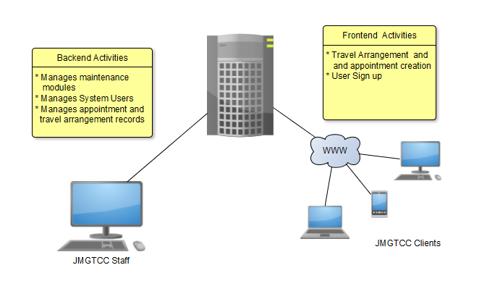

## 2.2 Product Functions

The following are description of the major functions of the travel arrangement and appointment system:

Backend

* Create Staff Record
* Allows the management to add new staff in their database.
* Management of Travel Arrangement
* Is triggered by an external entity or JMGTCC registered system users
* Enables the management to view and update the travel arrangement made.
* Management of Appointment Schedule
* Triggered by an external entity or JMGTCC user
* Allows the management to view and update the appointment made.

Frontend

* Create New Client Record
* Allows the external users to create their accounts and is added to the database.
* Create New Travel Arrangement
* Is triggered by an external entity and managed by the backend users
* Enables the user to mix and match their own travel and tour arrangement
* Schedule Visa Appointment
* Triggered by an external entity of both registered and unregistered users.
* Allows users to schedule an appointment for Visa application

Context flow diagram depicting the interaction between the system itself and the actors:

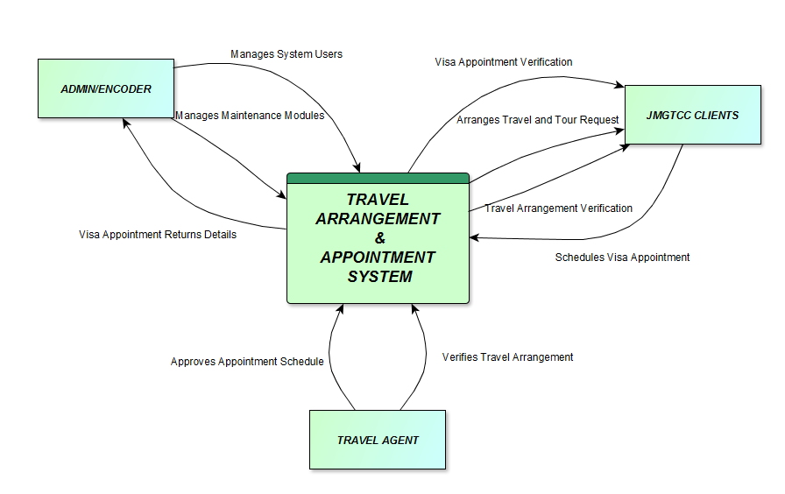

## 2.3 User Classes and Characteristics

The project’s purpose is to automate the process of arranging travel and tours of clients and scheduling an appointment for visa applicants resulting to a more efficient, convenient and accurate maintenance of records. The users of this project do not need to have college degree to utilize it as long as the user knows JMGTCC standards and policies in the appointment and travel arrangement aspect. The system has a wide variety of users since it operates both internally and externally. The expected internal users will be the travel agents or the staffs of JMGTCC and the external clients are mainly anyone who is interested in making arrangements with the agency

## 2.4 Operating Environment

The following are the software and hardware requirements to run the product:

* The system can run in any web browser available (e.g. Mozilla Firefox, Google Chrome, Internet Explorer, Opera Mini and etc.)
* The system shall operate on Apache web server.
* The backend of the system shall allow internal user access only and it should not be accessed by clients outside.
* The frontend of the system is accessible by anyone.

## 2.5 Design and Implementation Constraints

Since the system can run externally security issues must be observed. Other constraints such as limited memory and processing power are also worth considering. The system is meant to be efficient since the agency’s client appointment and travel arrangement is stored on the system and updates are done almost every day, which is why a quick and responsive system is needed.

## 2.6 User Documentation

The travel arrangement and appointment system is new to everybody in the agency and to the clients of the agency. To let the staff and clients adapt with this new environment easily, the user interface of the system is easy to use as possible and forms are similar to the standard that they follow. To provide supplementary information the system has an online support for the frontend users and the backend has a corresponding user manual and help menu.

The support tab can be accessed directly from the system application and from there; staff from the agency can answer customer inquiries through live chat.

The user manual is included in the system package although it cannot be found within the system itself. The manual contains a more specific description of the system usage.

## 2.7 Assumptions and Dependencies

The verification of travel arrangement and appointment is still manually processed and notification is still through email, although the system still works even without it. It is still a feature that can be added and automated later on.

The system’s online support is fairly dependent on the staff of JMGTCC since there is no AI to answer customer inquiries. The travel arrangement and visa appointment has to be approved by the staff of JMGTCC though the system can still work and can later be updated by the staff whenever they are online.

# 3. External Interface Requirements

## 3.1 User Interfaces

The Yii advanced framework have two user interface. These are the frontend and backend interface. Their difference is that the frontend is usually for their clients’ use, while the backend is for the management who would manage the system.

**Frontend**

* Allotted to the clients of JMGTCC.
* Navigations:
  + - Home
    - Travel and Tours Arrangement
    - Create
    - Update
    - Tours Arrangement
    - Create
    - Update
    - Visa Assistance Appointment
    - Create
    - Cancel existing appointment
    - Log in / Log out
    - Customer Help Desk/Support
* Data selections:
  + - Dropdown list
    - Text boxes / Text Areas
    - Check Box
* Authentication: Log in / Log out
  + Username Area
  + Password Area

**Backend**

* Allotted to the management of JMGTCC
* Navigations:
  + - Partner Airlines
  + CRUD functionality
    - Partner Hotels
  + CRUD functionality
    - User Roles
  + CRUD functionality
    - Users
  + CRUD functionality
    - Contact Numbers
  + CRUD functionality
    - Inclusions / Accommodations
  + CRUD functionality
    - * Tour Type
      * Transport Services
      * Food Inclusions
      * Other Inclusions
* Data selections:
  + Text boxes / Text Areas
* Authentication: Log in / Log out
  + Username Area
  + Password Area

## 3.2 Hardware Interfaces

* Dedicated PC / Laptop
  + Min. Intel Pentium
  + 8 Gigabyte RAM
  + 4 Gigabyte hard Drive
  + VGA color monitor
  + 32 bit network adapter card
  + External modem (opt. for remote configuration and support)
* Dedicated Server
* Android (4.2.2 and above) Mobile

## 3.3 Software Interfaces

* Microsoft Windows 7 and above
* 32 / 64 bit Windows
* Web Server Application
  + Windows Server 2003
  + Windows Server 2008 *(recommended)*

## 3.4 Communications Interfaces

* Browser
  + Firefox
  + Google Chrome
  + Internet Explorer
  + Opera Mini
* Communication Standards
  + HTTP / HTTPS
  + FTP

# 4. System Features

## 4.1 Create New User Account

### 4.1.1. Description and Priority

This feature is dedicated to all the clients of JMGTCC who wanted to have an official account in the system. This is feature is only optional for clients who only wanted to create a travel arrangement, but it becomes a requirement if the client needs to have a schedule for visa appointment

### 4.1.2. Stimulus/ Response Sequences

* Client wants to register for an account
* Response
  + Display registration form
  + Validate user input
  + Save data to database

### 4.1.3 Functional Requirements

The client must fill-up all the required fields of the form and ensure that all the data entered are valid. If any of these conditions are not met, then the client cannot successfully register to the system.

## 4.2 Create New Travel Arrangement

### 4.1.1. Description and Priority

This feature is dedicated to all the clients of JMGTCC. This is where their clients must fill-up the arrangement form or choose from all the possible options to customize their own travel and tours arrangement. This is considered as high priority since it is one of the main function of the system.

### 4.2.2. Stimulus/ Response Sequences

* Client wants to create a travel and tour arrangement
* Response
  + Display arrangement form
  + Validate user input
  + Save data in database
  + Notify travel agent
* Client wants to update existing travel and tour arrangement
* Response
  + Validate existing travel and tour arrangement
  + Validate user input
  + Update record in database
  + Notify travel agent

### 4.2.3 Functional Requirements

The client must fill-up all the required fields of the form and ensure that all the data entered are valid. If any of these conditions are not met, then the client cannot successfully save the travel arrangement form.

## 4.3 Schedule Visa Appointment

### 4.3.1. Description and Priority

This feature is restricted only to the clients of JMGTCC who are officially registered to the system. The reason why it became limited was to lessen the risk of having fake clients and also to strictly accommodate one (1) client per hour.

### 4.3.2. Stimulus/ Response Sequences

* Client wants to create a schedule for visa assistance appointment.
* Response
  + Confirm Client Account
  + Display Visa Appointment form
  + Validate user input
  + Verify date and time availability
  + Save data in database
  + Notify travel agent
* Client wants to update schedule for visa assistance appointment.
* Response
  + Cancel existing schedule for visa assistance appointment and save it to Appointment History table
  + Display Visa Appointment form
  + Validate user input
  + Save data in database
  + Notify travel agent

### 4.3.3. Functional Requirements

* There must be an existing account for any JMGTCC clients who wanted to access this feature.
* The client can only reserve the chosen time and date, if there is no existing schedule for that time and day.
* If the client wanted to re-schedule the appointment date or time, old record must be deleted from the table and moved to a new table called “Appointment History”

# 5. Other Nonfunctional Requirements

## 5.1 Performance Requirements

* The system shall accommodate as many clients as what the server it is being run from can handle
* The load time for each page or user interface screens shall take no longer than two to three seconds
* Responses to queries should be within 5 seconds
* User input validations and verification should be incorporated
* The system shall display appropriate notification or error messages

## 5.2 Safety Requirements

The system will not affect the data stored outside of its servers or nor will it affect any applications installed within the internal network of the company.

## 5.3 Security Requirements

* Backend users are required to log in for all operations on the system
* The system shall permit only the admin to access all system modules
* Creating, updating and deleting of records are permitted to users who were given access and permission by the admin
* Frontend users are allowed to access the Appointment module
* Travel and Tour modules are only accessible to registered users
* All user passwords should be encrypted in the database

## 5.4 Software Quality Attributes

***Usability:***

The user interface should be usable and presented in an organized and easy to use manner.

***Availability****:*

The system backend is only accessible internally, within the company network.

The system frontend is accessible to clients, externally.

***Maintainability:***

The system is easy to maintain with proper usage and care.

***Reliability and Correctness****:*

The information encoded through the system is ensured and accurate.

All data saved in the database is based on the user input provided.

## 5.5 Business Rules

The system admin is permitted to access all the system modules.

User roles and permissions are dynamically created and distributed to each backend user.

The table shows the proposed staff hierarchy and module availability:

|  |  |
| --- | --- |
| Role | Accessible modules |
| Admin | * All Backend modules |
| Manager | * Create, Update, Delete &View *users* * Create, Update, Delete &View *roles* * Create, Update, Delete &View *airlines* * Create, Update, Delete &View *contact number* * Create, Update, Delete &View *travel / tour inclusions* * Create, Update, Delete &View *time* * Create, Update, Delete &View *tour type* * Create, Update, Delete &View *transport services* * View *appointments* * Update *appointments* * View *tour arrangement requests* * View *travel arrangement request* |
| Travel Agent | * View *appointments* * View *travel / tour inclusions* * View *tour type / transport services* * Update *travel / tour arrangement* |
| Encoder | * Create, Update, Delete &View *users* * Create, Update, Delete &View *roles* * Create, Update, Delete &View *airlines* * Create, Update, Delete &View *contact number* * Create, Update, Delete &View *travel / tour inclusions* * Create, Update, Delete &View *time* * Create, Update, Delete &View *tour type* * Create, Update, Delete &View *transport services* |
| Tech Support | * Manage Support module (live chat) |

# 6. Other Requirements

**Appendix A: Glossary**

* **Backend** isused as part of corporate management and they work by obtaining user input and gathering input from other systems to provide responsive output.
* **Frontend** is one that application users interact with directly.
* **Encoder** isthe person that inputs data into the system.
* **Tech Support –** user-friendly assistance for individuals having technical problems with electronic devices.

**Appendix B: Analysis Models**

**Appendix C: To Be Determined List**